14 Movie Clip Editor
Detailed Table of content 1
Tracking Mode - Track Panel 14
All Modes - Objects Panel 15
Tracking Mode - Plane Track Panel 16
Tracking Mode - Tracking Settings Panel 16
Tracking Mode - Camera Panel 17
Tracking Mode - Lens Panel 18
All Modes - Display Panel 19
Tracking Mode - Marker Panel 20
Tracking Mode - Marker Display Panel 20
Tracking Mode - 2D Stabilization Panel 21
All Modes - Proxy/Timecode Panel 23
All Modes - Footage Settings Panel 24
All Modes - Footage Information Panel 25
Mask Mode - Mask Settings Panel 25
Mask Mode - Mask Layers Panel 25
Mask Mode - Mask Display Panel 26
Mask Mode - Active Spline Panel 27
Mask Mode - Active Spline Panel 27

Detailed Table of content

3.5 - Movie Clip Editor
Detailed Table of content 2
Tracking Introduction 15
Manual Lens Calibration 15
Camera and Object Motion Solving 15
Tools for Scene Orientation and Stabilization 15
Movie Clip Editor Introduction 16
Marker 16
Track 17
Short tutorial 17
Preparing the video 17
Tracking the object 19
Orientation and dimensions 20
Reloading a project 20
Clip Editor, Gaph Editor and Dopesheet Editor 20
Clip Editor 21
Graph Editor 21
Dopesheet Editor 22
Clip Editor Introduction 22
Clip Editor general navigation 22
Clip Editor - Tracking and Mask Mode 23
Tool Shelf - Grease Pencil 23
Grease Pencil Panel 24
Draw 24
Draw 24
Erase 24
Line 24
Poly 24
Eraser Radius 24
Insert Blank Frame 24
Delete frames 24
Draw Settings 24
Additive Drawing 24
Continuous Draw 25
Eraser in Continuous Draw 25
End Continuous Draw 25
Draw on Back 25
Stroke Placement 25
View 25
Cursor 25
Enable Editing 25
Edit Strokes Panel 25
Select 26
Select All 26
Border Select 26
Circle Select 26
Select Linked 26
Select More 26
Select Less 26
Select Color 26
Edit 27
Translate 27
Last Operator Translate 27
Vector 27
Constraint Axis 27
Orientation 27
Proportional Editing 27
Proportional Editing Falloff 27
Proportional Size 27
Edit Grease Pencil 28
Edit Texture Space 28
Rotate 28
Last Operator Translate 28
Angle 28
Constraint Axis 28
Orientation 28
Proportional Editing 28
Proportional Editing Falloff 28
Proportional Size 28
Edit Grease Pencil 28
Scale 28
Last Operator Resize 29
Vector 29
Constraint Axis 29
Orientation 29
Proportional Editing 29
Proportional Editing Falloff 29
Proportional Size 29
Edit Grease Pencil 29
Edit Texture Space 29
Mirror 29
Last Operator Mirror 29
Constraint Axis 29
Orientation 30
Proportional Editing 30
Proportional Editing Falloff 30
Proportional size 30
Edit Grease Pencil 30
Confirm on Release 30
Shear 30
Last Operator Shear 30
Offset 30
Proportional Editing 30
Proportional Editing Falloff 30
Edit Grease Pencil 30
Confirm on Release 31
To Sphere 31
Last Operator To Sphere 31
Factor 31
Proportional Editing 31
Proportional Editing Falloff 31
Proportional Size 31
Edit Grease Pencil 31
Confirm on Release 31
Arrange Strokes 31
Move to Color 32
Subdivide 32
Last Operator Subdivide Stroke 32
Number of Cuts 32
Join 32
Last Operator Join Strokes 32
Type 32
Leave Gaps 32
Join & Copy 32
Flip Direction 32
Sculpt Strokes Panel 33
Sculpt Strokes Button 33
Radius 33
Strength 33
Use Falloff 33
Position 33
Strength 33
Thickness 33
Selection Mask 33
Alpha 33
Affect Pressure 34
Drawing Brushes panel 34
Brushes selection box 34
Thickness 34
Sensitivity 34
Strength 34
Randomness 34
Jitter 34
Angle 34
Factor 34
Smooth 34
Iterations 34
Subdivision 34
Randomness 35
Brush Curves Panel 35
Properties Sidebar - Grease Pencil - Layers Panel 35
Grease Pencil Prop 35
New Layer 36
Layer list 36
Add / Delete 36
Layer Specials menu 36
Duplicate Layer 36
Show All 36
Hide Others 36
Lock All 37
Unlock All 37
Merge Down 37
Move Up / Move down 37
Lock Unlock unselected / Show Hide unselected 37
Opacity 37
X Ray 37
Show Points 37
Tint 37
Thickness Change 38
Lock Frame 38
Onion Skinning 38
Onion Skinning checkbox 38
Use always ghosts 38
Use custom colors 38
Before 38
After 38
Properties Sidebar - Grease Pencil - Colors Panel 39
GP Palette 39
Color List 39
Add / Delete 39
Palette color Specials menu 39
Show All 39
Hide Others 39
Lock All 40
Unlock All 40
Copy color 40
Select strokes 40
Move to color 40
Strokecolor 40
Volumetric Strokes 40
Fill 40
High Quality Fill 41
All Modes - Header - View Menu 41
Properties 41
Tools 41
View Selected 41
View All 41
View Fit 42
View Zoom Out 42
Zoom 1:8 ... Zoom 8:1 42
Duplicate Area into new Window 42
Toggle Full screen Area 42
Toggle Maximize Area 43
All Modes - Header - Clip menu 43
Open Clip 43
Prefetch Frames 43
Reload Clip 43
Proxy 43
Rebuild Proxy and Timecode Indices 43
Delete Proxy 43
Set Solver Keyframe A 44
Set Solver Keyframe B 44
All Modes - Header - Tools 44
Clip Browser 44
Clip browser 44
Edit Box 44
Number of users 44
Fake User 44
Open Clip 44
Delete Clip 44
Mode dropdown box 45
Clip Editor Type 45
Pivot Point 45
Bounding Box Center 45
2D Cursor 45
Individual Origins 45
Median Point 45
Tracking Mode - Select Menu 45
Border Select 45
Circle Select 46
(De)Select All 46
Last Operator (De)Select All 46
Action 46
Invert 46
Deselect 46
Select 46
Toggle 46
Inverse 46
Grouped tracks 46
Last Operator Select Grouped 47
Tracking Mode - Header Tools 47
Info String 47
Tracking Mode - Track menu 47
Clear Solution 47
Clear Track Path 47
Last Operator Clear Track Path 48
Action 48
Clear Active 48
Lock 48
Unlock 48
Last Operator Lock Tracks 48
Action 48
Copy 48
Paste 48
Insert Keyframe 48
Delete Keyframe 48
Show / Hide 49
Show Hidden 49
Hide Selected 49
Hide Unselected 49
Last Operator Hide Tracks 49
Unselected 49
Transform 49
Translate 49
Last Operator Translate 49
Move 49
Proportional Editing 49
Proportional Editing Falloff 50
Proportional size 50
Edit grease Pencil 50
Edit Texture Space 50
Rotate 50
Last Operator Rotate 50
Values 50
Proportional Editing 50
Proportional Editing Falloff 50
Proportional size 50
Edit grease Pencil 50
Resize 50
Last Operator Resize 51
Scale 51
Proportional Editing 51
Proportional Editing Falloff 51
Proportional size 51
Edit grease Pencil 51
Edit Texture Space 51
Reconstruction 51
Tracking Mode - Tool Shelf 52
Track Tab and Solve Tab 52
Grease Pencil tab 52
Tracking Mode - Tool Shelf - Track tab - Clip Panel 52
Set Scene Frames 52
Tracking Mode - Tool Shelf - Track tab - Marker Panel 52
Detect Features 53
Last Operator Detect Features 53
Placement 53
Whole frame 53
Inside Grease Pencil 53
Outside Grease Pencil 53
Margin 53
Threshold 53
Distance 53
Add Marker 54
Last Operator Add Marker at Click 54
Enable Markers 54
Disable Markers 54
Last operator Disable Markers 54
Action 54
Delete Marker 54
Delete Track 54
Tracking Mode - Tool Shelf - Track tab - Tracking Settings Panel 54
Tracking Presets 54
R G B 55
Pattern Size 55
Search Size 55
Motion 55
Match 55
Prepass 55
Normalize 55
Copy from Active Track 55
Extra Settings 55
Use Mask 55
Correlation 56
Frames Limit 56
Margin 56
Weight 56
Tracking Mode - Tool Shelf - Track tab - Track Panel 56
Track 56
Clear 56
Last Operator Clear Track Path 56
Action 56
Clear active 56
Refine 57
Backwards 57
Merge 57
Tracking Mode - Tool Shelf - Solve tab - Plane Track Panel 57
Tracking Mode - Tool Shelf - Solve tab - Solve Panel 58
Tripod 58
Keyframe 58
Keyframe A 58
Keyframe B 58
Refine 58
Solve Camera Motion 59
Tracking Mode - Tool Shelf - Solve tab - Cleanup Panel 59
Clean Tracks 59
Last Operator Clean Tracks 59
Frames 59
Error 59
Select 59
Frames 59
Error 60
Select 60
Filter Tracks 60
Tracking Mode - Tool Shelf - Solve tab - Geometry Panel 60
3D Markers to Mesh 60
Link Empty to Track 60
Tracking Mode - Tool Shelf - Solve tab - Orientation Panel 60
Floor 60
Wall 60
Last Operator Set Plane 60
Plane 60
Set Origin 61
Last Operator Set Origin 61
Use Median 61
Set X Axis 61
Set Y Axis 61
Last Operator Set Axis 61
Axis 61
Set Scale 61
Last Operator Set Scale 61
Distance 61
Apply Scale 61
Last operator Apply Solution Scale 61
Distance 61
Distance 62
Tracking Mode - Tool Shelf - Solve tab - Scene Setup Panel 62
Set as Background 62
Setup Tracking Scene 62
Tracking Mode - Properties Sidebar - Track Panel 62
Edit Box 62
Enable 62
Lock 62
Track Scope 62
Color Settings 63
R, G, B 63
B/W 63
Alpha 63
Weight 63
Stabilization Weight 63
Average Error 63
Marker Color 63
Color Preset 63
Copy 64
Add Preset, Remove Preset 64
Custom Color 64
All Modes - Properties Sidebar - Objects Panel 64
Add, Remove Tracking Object 64
Search Field 64
Tracking Mode - Properties Sidebar - Plane Track Panel 64
Name 64
Auto Keyframe 64
Image 65
Opacity 65
Tracking Mode - Properties Sidebar - Tracking Settings Panel 65
Motion Model 65
Match 65
Prepass 65
Normalize 65
Use Mask 65
Correlation 65
Frames Limit 66
Margin 66
Speed 66
Tracking Mode - Properties Sidebar - Camera Panel 66
Presets 66
Add / Remove Camera Preset 66
Sensor 66
Width 66
Pixel Aspect Ratio 66
Optical center 66
Center 66
Tracking Mode - Properties Sidebar - Lens Panel 67
Focal length 67
Lens Distortion 67
All Modes - Properties Sidebar - Display Panel 67
Color settings 67
R G B 67
B / W 67
Mute Footage 67
Render Undistorted 68
Lock to Selection 68
Display Stabilization 68
Grid 68
Calibration 68
Display Aspect Ratio 68
Show Metadata 68
Tracking Mode - Properties Sidebar - Marker Panel 68
Enabled 68
Position 68
Offset 69
Pattern Area 69
Search Area 69
Tracking Mode - Properties Sidebar - Marker Display Panel 69
Pattern 69
Path 69
Disabled 69
3D Markers 69
Search 69
Length 69
Info 69
Thin 70
Tracking Mode - Properties Sidebar - 2D Stabilization Panel 70
Anchor Frame 70
Rotation/Scale 70
Tracks for Location 70
Tracks for Rotation/Scale 70
Autoscale 71
Max 71
X / Y 71
Expected Rotation 71
Expected Scale 71
Influence 71
Interpolate 71
All Modes - Properties Sidebar - Proxy/Timecode Panel 71
Build Original 72
Build Undistorted 72
Quality 72
Proxy Custom Directory 72
Build Proxy / Timecode 72
Use Timecode Index 72
Proxy Render Size 72
All Modes - Properties Sidebar - Footage Settings Panel 72
File Path 73
Color Space 73
Start Frame 73
Frame Offset 73
All Modes - Properties Sidebar - Footage Information Panel 73
Masking Introduction 73
S-Curves 74
Mask Mode - Header - Select Menu 74
Border Select 74
Circle Select 75
Select All 75
Select Linked 75
Select More 75
Select Less 75
Mask Mode - Header - Mask Menu 75
Delete 75
Duplicate 75
Clear Parent 75
Make Parent 76
Copy Splines 76
Paste Splines 76
Show Hide 76
Show Hidden 76
Last operator Show Hidden Layer 76
Select 76
Hide Selected 76
Hide Unselected 76
Last Operator Hide Layer 76
Unselected 76
Transform 77
Translate 77
Last Operator Translate 77
Move 77
Proportional Editing 77
Proportional Editing Falloff 77
Proportional size 77
Edit grease Pencil 77
Edit Texture Space 77
Rotate 77
Last Operator Rotate 77
Values 77
Proportional Editing 77
Proportional Editing Falloff 78
Proportional size 78
Edit grease Pencil 78
Scale 78
Last Operator Resize 78
Scale 78
Proportional Editing 78
Proportional Editing Falloff 78
Proportional size 78
Edit grease Pencil 78
Edit Texture Space 78
Scale Feather 78
Last Operator Transform 78
Values 79
Proportional Editing 79
Proportional Editing Falloff 79
Proportional size 79
Edit grease Pencil 79
Mask Mode - Header - Mask tools 79
Mask Browser 79
Mask browser 79
Edit Box 79
Number of users 79
Fake User 79
New Mask 79
Delete Mask 80
Proportional Editing 80
Proportional Editing Falloff 80
Mask Mode - Tool Shelf - Mask tools panel 80
Add Spline section 80
Add Circle 80
Last Operator Add Circle 80
Size 80
Location 80
Add Square 81
Last Operator Add Square 81
Size 81
Location 81
Spline Section 81
Delete 81
Toggle Cyclic 81
Switch Direction 81
Set Handle Type 81
Last Operator Set Handle Type 81
Type 81
Clear Feather Weight 81
Animation section 81
Insert Key 81
Clear Key 82
Reset Feather Animation 82
Re Key Shape Points 82
Mask Mode - Properties Sidebar - Mask Settings Panel 82
Mask Mode - Properties Sidebar - Mask Layers Panel 82
List Box 82
Add / Remove Layer 82
Move Layer upwards / downwards 82
Opacity 83
Blend 83
Falloff 83
Overlap 83
Holes 83
Mask Mode - Properties Sidebar - Mask Display Panel 83
Smooth 83
Edge Draw Type 83
Overlay 83
Overlay Mode 84
Combined 84
Alpha Channel 84
Mask Mode - Properties Sidebar - Active Spline Panel 84
Feather Offset 84
Weight Interpolation 84
Cyclic 84
Fill 84
Self Intersection Check 84
Mask Mode - Properties Sidebar - Active Spline Panel 84
Parent 84
Point Track / Plane Track 84
Object 85
Track 85
Graph Editor Introduction 85
Graph Editor general navigation 85
Graph Editor - View Menu 86
Show Seconds 86
Lock Time to Other Windows 86
Center Current Frame 86
View All 86
Duplicate Area into new Window 86
Toggle Full screen Area 87
Toggle Maximize Area 87
Graph Editor - Select Menu 87
Border Select 87
(De)select All Markers 87
Inverse 87
Graph Editor - Graph Menu 88
Delete Curve 88
Delete Knot 88
Clear Track Path Remained 88
Clear Track Path Up To 88
Clear Track Path All 88
Disable Markers 88
Translate 88
Resize 88
Rotate 88
Graph Editor - Header Tools 88
Show Selected 88
Display Hidden 89
Filters 89
Show Frames 89
Show Track Motion 89
Show Track Error 89
Dopesheet Editor - Intro 89
Dopesheet Editor 89
Dopesheet Editor general navigation 90
Dopesheet Editor - View menu 90
Show Seconds 90
Lock Time to Other Windows 90
Duplicate Area into new Window 90
Toggle Full screen Area 90
Toggle Maximize Area 91
Dopesheet Editor - Header Tools 91
Dopesheet Sort Field 91
Invert 91

Tracking Mode - Track Panel
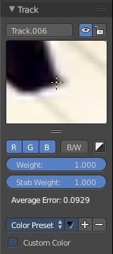
Here you can find some marker settings for the currently selected marker.

Edit Box
Here you can read and edit the name of the currently selected marker.

Enable
Enable the currently selected marker.

Lock
Lock the currently selected marker.

Track Scope
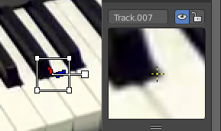
This is a preview image and fine tune window for the currently selected marker. The fade cross stays always in the center, but you can move the image with the left mouse. This automatically records the changed position, and inserts a keyframe at the current position if necessary.
You can pull it vertically bigger by pulling at the handler below the image. And horizontally bigger by pulling out the properties sidebar.
If an anchor is used (the position in the image which is tracking is different from the position which is used for parenting), a preview widget will display the area around the anchor position.

Color Settings

R, G, B
Use red, green and blue color in the preview image.

B/W
Use a greyscale preview image.

Alpha
Use existing alpha channel for preview image.

Weight
The influence of this track to the final solution. Altering the weights of problem tracking markers can correct or greatly reduce undesirable jumps. This parameter can be animated.

Stabilization Weight
The influence of this track on 2D stabilization.

Average Error
The average error of this marker.

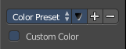
Marker Color
Here you can give the markers different colors.

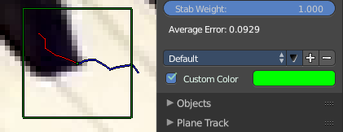

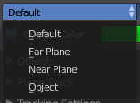
Color Preset
A dropdown box where you can choose between some predefined colors.

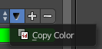
Copy
Here you can copy the color of the currently chosen preset.

Add Preset, Remove Preset
Here you can add a new or remove a existing preset.

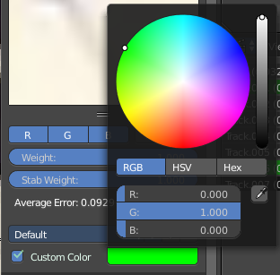
Custom Color
Use a custom color instead of a preset or the default color. A color field will appear. And you can change the color by clicking at it. A color picker will appear.

All Modes - Objects Panel

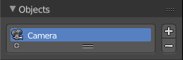
This content shows in Tracking Mode and Masking mode.

A list of the tracked objects. Usually the camera. But you can track every other object too.

Add, Remove Tracking Object
The plus and minus buttons at the right allows you to add new objects to the list, or to remove existing objects from the list.

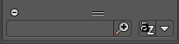
Search Field
The list field contains a hidden search field. Click at the little + button down left to reveal it.

Tracking Mode - Plane Track Panel

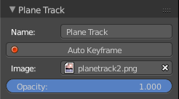
This content is just active and visible when you have a Plane track in your footage.

Name
The name of the Plane track.

Auto Keyframe
Use Auto Keyframe when moving plane track corners.

Image
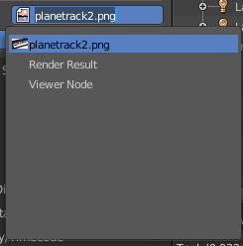
Here you can see and load images or movies that you want to display inside of the Plane track. Note that this image needs to exist already so that it gets displayed in the list. As a image node for example.

Opacity
The opacity of the image or movie.

Tracking Mode - Tracking Settings Panel

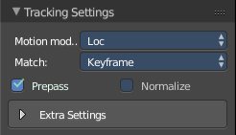
This content is visible when you have at least one of the markers selected.

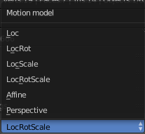
Motion Model
Here you can choose the motion model for the marker.

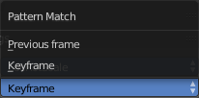
Match
Here you can choose the pattern match method.

Prepass
Use a brute-force translation only pre-track before refinement.

Normalize
Normalize light intensities while tracking.
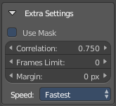
Extra settings is a sub menu that contains some not so often used settings.

Use Mask
Use a Grease Pencil data block as a mask.

Correlation
Default minimum value of correlation between matched pattern and reference that is still treated as successful tracking.

Frames Limit
In every tracking cylce the numbers of given frames are tracked.

Margin
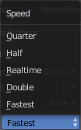
Default distance from image boundary at which markers stops tracking.

Speed
A dropdown box where you can choose the tracking speed. This is just a preview feature. The tracking quality is not affected.

Tracking Mode - Camera Panel

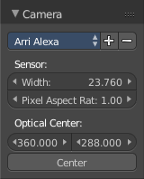
Here you can choose the settings for the camera with which you have recorded the footage movie. Every camera has some specific settings. And this needs to be calculated too to match the footage to the 3D content.

Presets
A dropdown box where you can choose between different camera presets. When your camera is not listed then you need to do the settings manually.

Add / Remove Camera Preset
Here you can add a new preset or remove an existing preset

Sensor
The sensor width and pixel aspect ratio of your camera.

Width
The width of the CCD Sensor in your used camera. This value can be found in the camera specifications.

Pixel Aspect Ratio
The Pixel Aspect of the CCD Sensor in your used camera. This value can be found in the camera specifications.
This value ccan also be guessed. For example, when the footage should be 1920×1080, but the images themselves are 1280×1080, then the pixel aspect is: 1920 / 1280 = 1.5.

Optical center
The optical center. Usually in the middle of the movie. But some cameras also have an offset here.

Center
Center the optical center.
In most cases it is equal to the image center, but it can be different in some special cases. Check camera/lens specifications in such cases. To set the optical center to the center of image, there is a Return button below the sliders.

Tracking Mode - Lens Panel

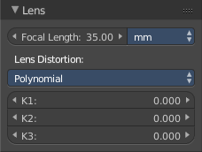
This panel belongs to the Camera panel above. Here you can type in your lens values from the camera with which you have recorded your footage movie.

Focal length
The focal length units with which the movie was shot. You can choose between milimeter and pixel.

Lens Distortion
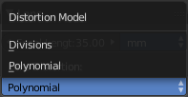
The lens distortion of your camera. You can choose between two distortion models. Polynomial and Divisions.
Basically, just tweak K1 until solving is most accurate for the known focal length (but also take grid and grease pencil into account to prevent “impossible” distortion).
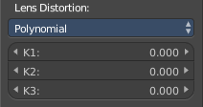
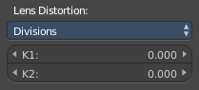

All Modes - Display Panel
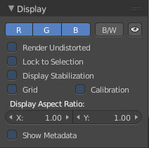
This content shows in Tracking Mode and Masking mode.

Here you can adjust how the movie in the movie clip editor viewport gets displayed.

Color settings

R G B
Here you can activate single colors.

B / W
Display the footage movie in greyscale.

Mute Footage
Hide the footage movie.

Render Undistorted
Display the footage movie undistorted, without the camera and lens settings.

Lock to Selection
Locks the display to selected markers through playback. Means the marker stays in position, and the movie moves.

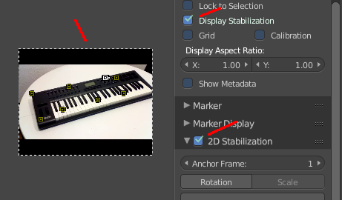
Display Stabilization
Show stable footage movie in the viewport. 2D Stabilization must be enabled for this.

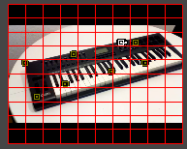
Grid
Displays a grid above the footage movie.

Calibration
Use manual calibration helpers.

Display Aspect Ratio
The aspect ratio of the footage movie.

Show Metadata
Displays the metadata of the movie if available.

Tracking Mode - Marker Panel
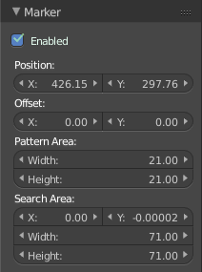
The Marker panel contains the settings for the selected marker(s).

Enabled
Enable the selected marker(s).

Position
The position of the selected marker(s) in pixel. Zero is down left.

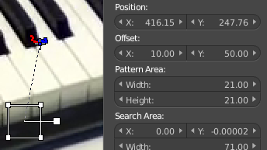
Offset
You can give the marker handler an offset. So that it gets displayed besides the marker.

Pattern Area
The handler size.

Search Area
The size and position of the search area for this marker for tracking.

Tracking Mode - Marker Display Panel
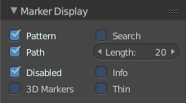

Pattern
Display the marker handler.

Path
Display the marker paths.

Disabled
Show disabled tracks from the footage.

3D Markers
Shows the 3D markers from the 3D view as colored dots. The color of the point depends on the distance between the projected coordinate and the original coordinate: if they are close enough, the point is green, otherwise it will be red.

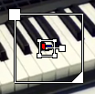
Search
Shows a handler cage for the search area for the marker(s).

Length
This belongs to the path. Here you can adjust how many frames the path should display.

Info
Displays a info string below the markers

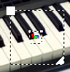
Thin
Displays the handlers as thin dotted lines instead of thick lines.

Tracking Mode - 2D Stabilization Panel
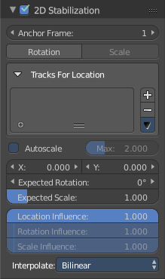
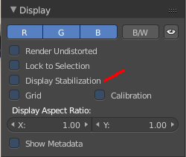

The purpose of 2D Stabilization is to smooth out jerky camera handling on existing real world footage. To activate the 2D stabilizer, you need to set the toggle in the panel, and additionally you need to enable Display Stabilization in the Display panel. Then you’ll need to set up some tracking points to detect the image movements.
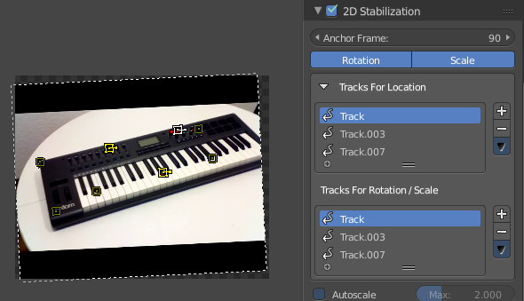

Anchor Frame
The first frame of the stabilization.

Rotation/Scale
Normally you just stabilize the position. Here you can stabilize rotation and scale too. Note that you can't activate scale independently here.

Tracks for Location
The list of markers that gets used for location stabilization.
With the plus and minus button at the right you can add selected markers, or remove the markers from the list.

Tracks for Rotation/Scale
The list of markers that gets used for rotation/scale stabilization.
With the plus and minus button at the right you can add selected markers, or remove the markers from the list.
This list is just visible when you have at least Rotation activated.

Autoscale
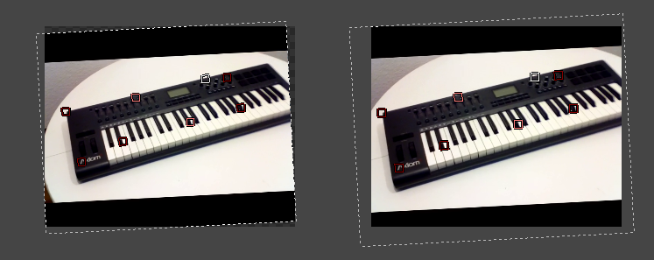
The stabilization will lead to areas where the movie doesn't show at the canvas anymore. Autoscale scales the content so that the whole canvas is covered again.

Max
The maximum value for autoscale.

X / Y
The position of the movie at the canvas.

Expected Rotation
Here you can rotate the movie at the canvas manually.

Expected Scale
Here you can scale the movie at the canvas manually. Note that this slider is greyed out when you have Autoscale activated

Influence
The influence of stabilization algorithm. You can independently adjust location, rotation and scale. When oyu have rotation off, then the sliders for rotation influence and scale influence are greyed out.

Interpolate
For rotation and scale the images needs to be recalculated. Here you can adjust the interpolation mode for it.

All Modes - Proxy/Timecode Panel

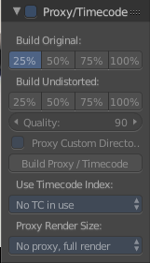
This content shows in Tracking Mode and Masking mode.

A proxy is a smaller replacement image for the main image. Think of it as a thumbnail. The creation may take some time. But once done, all other calculations happens much faster. So it can make sense to use proxies for bigger footages.
Make sure to disable the Proxy images before doing the final render!

Build Original
Here you can define the resolution of the proxy images.

Build Undistorted
Builds the proxy images from the undistorted original images for the sizes set above.

Quality
Defines the quality of the JPEG images used for proxies.

Proxy Custom Directory
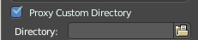
By default, all generated proxy images are storing to the <path of original footage>/BL_proxy/<clip name> folder. Here you can define a custom directory.

Build Proxy / Timecode
(Re)creates the proxy images and the timecode.

Use Timecode Index
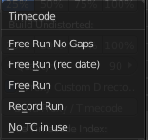
When you are working with footage directly copied from a camera without pre-processing it, then there might be a bunch of artifacts. In this case the calculation can give errant result. One way to avoid this is to use the Proxy / Timecode option. Another method would be to use a external tool like mencoder to repair the file header and insert correct keyframes.

Note
Record Run is recommended for most needs. Buf when the clip’s file is totally damaged, Record Run No Gaps will be the only chance of getting acceptable result.

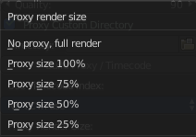
Proxy Render Size
This setting defines which proxy image resolution is used for display in the viewport. If there is no generated proxies, render size is set to “No proxy, full render”.

All Modes - Footage Settings Panel
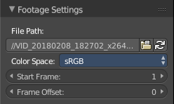
This content shows in Tracking Mode and Masking mode.

Here you can find some footage related settings.

File Path
The file path for the currently loaded and active video. Here you can also load another video, or refresh the video.

Color Space
The color space for the currently loaded and active video.

Start Frame
The start frame for the currently loaded and active video.

Frame Offset
Here you can define a frame offset.

All Modes - Footage Information Panel

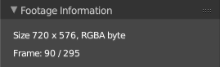
This content shows in Tracking Mode and Masking mode.

Here you can see some information about the footage movie.

Mask Mode - Mask Settings Panel

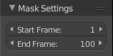
Here you can adjust the start and endframe for the mask.

Mask Mode - Mask Layers Panel

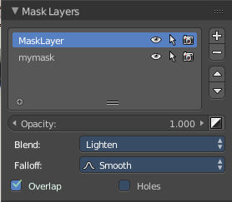
Here you handle the mask layers and their settings. You can have more than one mask layer in a mask. And they can be blended in different ways.

Layers can be used to create complex shapes and to define how the splines interact with each other. Splines belonging to the same layer can be animated together,

List Box
The list of currently existing Mask layers.
Double clicking at a name allows you to rename the mask layer.
The eye icon allows you to hide this specific layer.
The arrow icon allows you to make this layer unselectable.
The camera icon allows you to make this layer not to render.

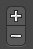
Add / Remove Layer
Here you can add a new layer, and remove an existing layer.

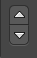
Move Layer upwards / downwards
Here you can move the selected layer upwards or downwards the hierarchy.

Opacity
The opacity of this layer.
The button at the right end inverts the mask in black and white.

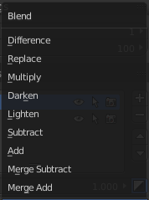
Blend
Layers can have different blend modes. The names of the blend modes should be self explaining.

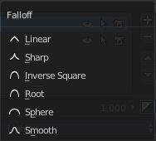
Falloff
The falloff mode for the feather spline.

Overlap
Calculate self intersections and overlap before filling.

Holes
Calculate holes when filling overlapping curves.

Mask Mode - Mask Display Panel

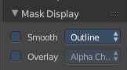
Here you can find some display options for the masks.

Smooth
Display the spline lines smoothed.

Edge Draw Type
How to draw the spline lines.

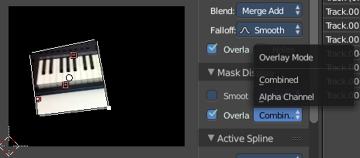
Overlay
Displays the mask in the footage. Masked areas are white.

Overlay Mode

Combined
Displays the footage in the mask area. Areas outside the mask are displayed black.

Alpha Channel
Displays the masked area white, the rest black.

Mask Mode - Active Spline Panel
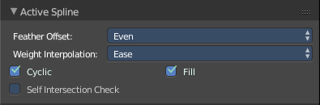
Here you can find some settings for the active mask spline.

Feather Offset
The offset method for the feather spline.

Weight Interpolation
The type of weight interpolation for this spline.

Cyclic
Is it a closed spline or one with two ends.

Fill
Make this spline filled.

Self Intersection Check
Prevent the feather spline from self intersecting.

Mask Mode - Active Spline Panel

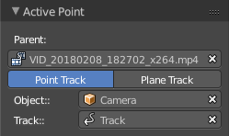
This panel content appears when you parent a spline to a marker. Here you can see and adjust the parent relationship for the currently active spline point.

Parent
The parent footage.

Point Track / Plane Track
The parent type. If you use point tracking here, or plane tracking.

Object
The tracking object. Usually the camera.

Track
The track / marker where this spline point is parented at.

